Design Review Report
  - RGA – Recording Guitar Amplifier

  - Andrew Carlisle – acarlisle8@gatech.edu
  - Kyle de Nobel – knobel3@gatech.edu
  - Joseph Sugijanto – jsugijanto3@gatech.edu
  - Marco Yaipen – myaipen3@gatech.edu

High Level Device Overview
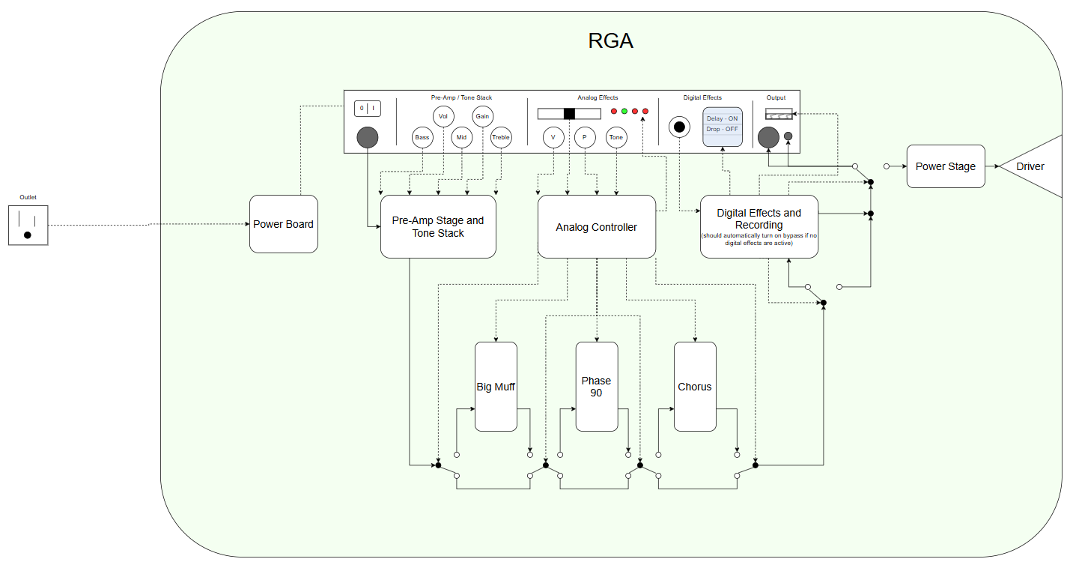
The figure above shows the high-level design of the device. All dashed lines are control lines for peripherals or are user inputs from the front face of the device. The solid lines show the signal path of the guitar as it travels through the device. Each rounded white box is an individual PCB board.

Presentation Overview
The presentation to Dr. Robinson is to gain feedback on what we have designed and developed so far as well as to demonstrate the progress of the project. The presentation was given on Wednesday, March 11th.
Items demonstrated during the presentation:
- Big Muff analog effect protoboard
- Overdrive analog effect protoboard
- Power stage components
- Digital effects via the daisy seed in a breadboard

The team decided on building these protoboards not only to showcase effect designs, but also as a backup if there is an issue with the PCBs that are planned to replace them. Each protoboard was used in isolation so that effect could be heard and analyzed without the interference from another effect. This presentation did not cover listening to every protoboard made, as phase 90 and pre-amp stage and tone stack were just visually shown during the presentation. The power stage was not made into a protoboard because the power BJTs used are too large to fit into a protoboard. We demonstrated the power stage by connecting to the BJTs via alligator clips and placed the other components into a breadboard.

Images of Each Protoboard Presented and The Driver

Phase 90
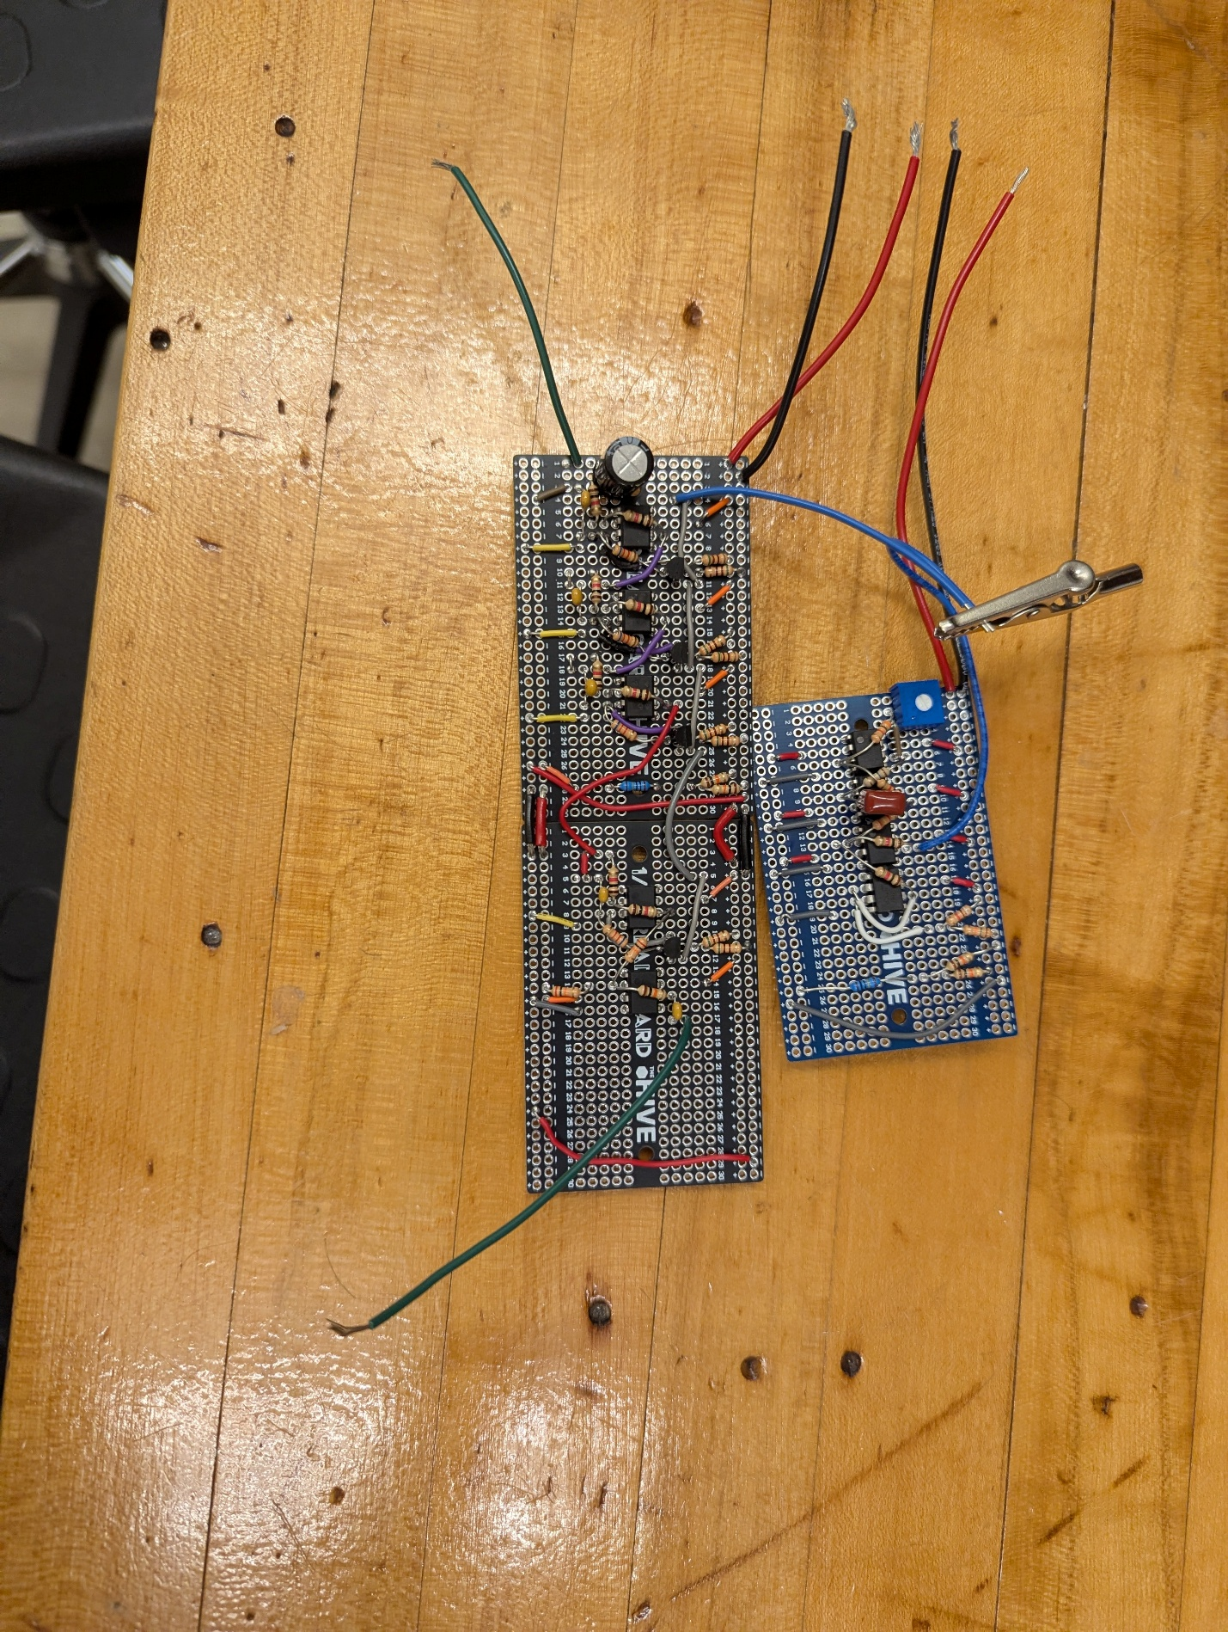

Overdrive
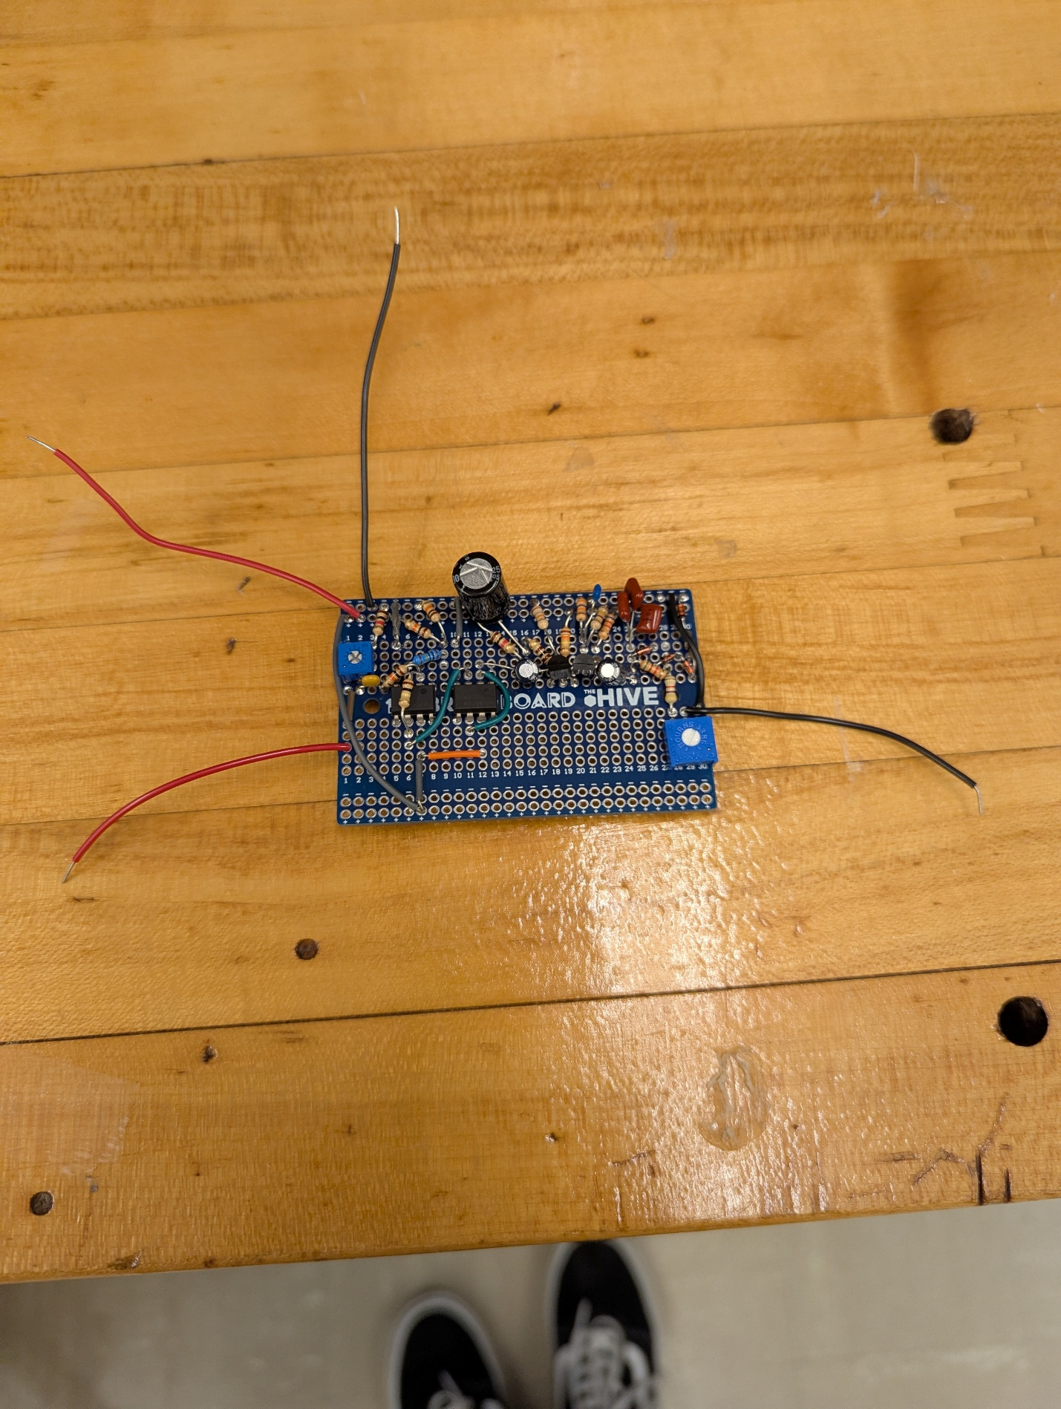

Big Muff
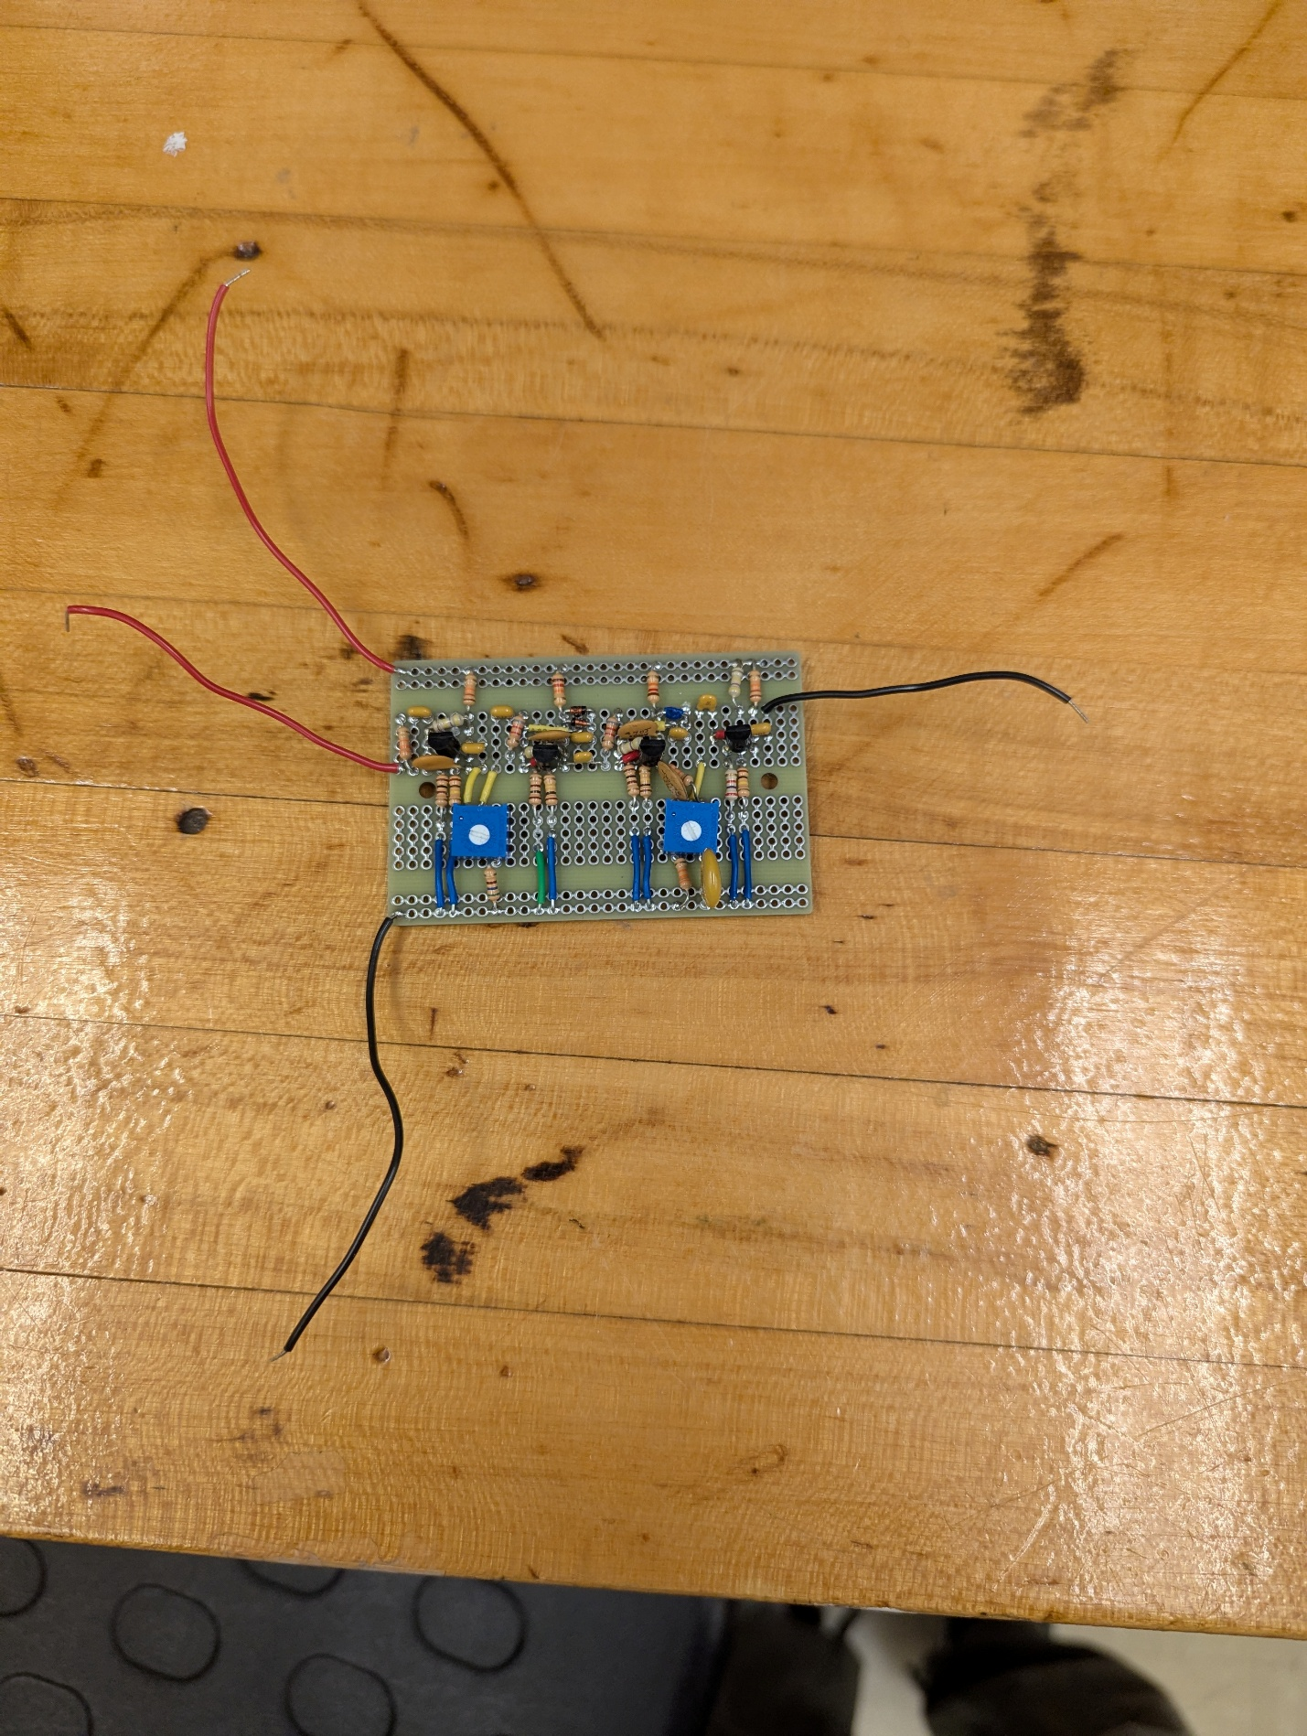

Pre-Amp and Tone Stack
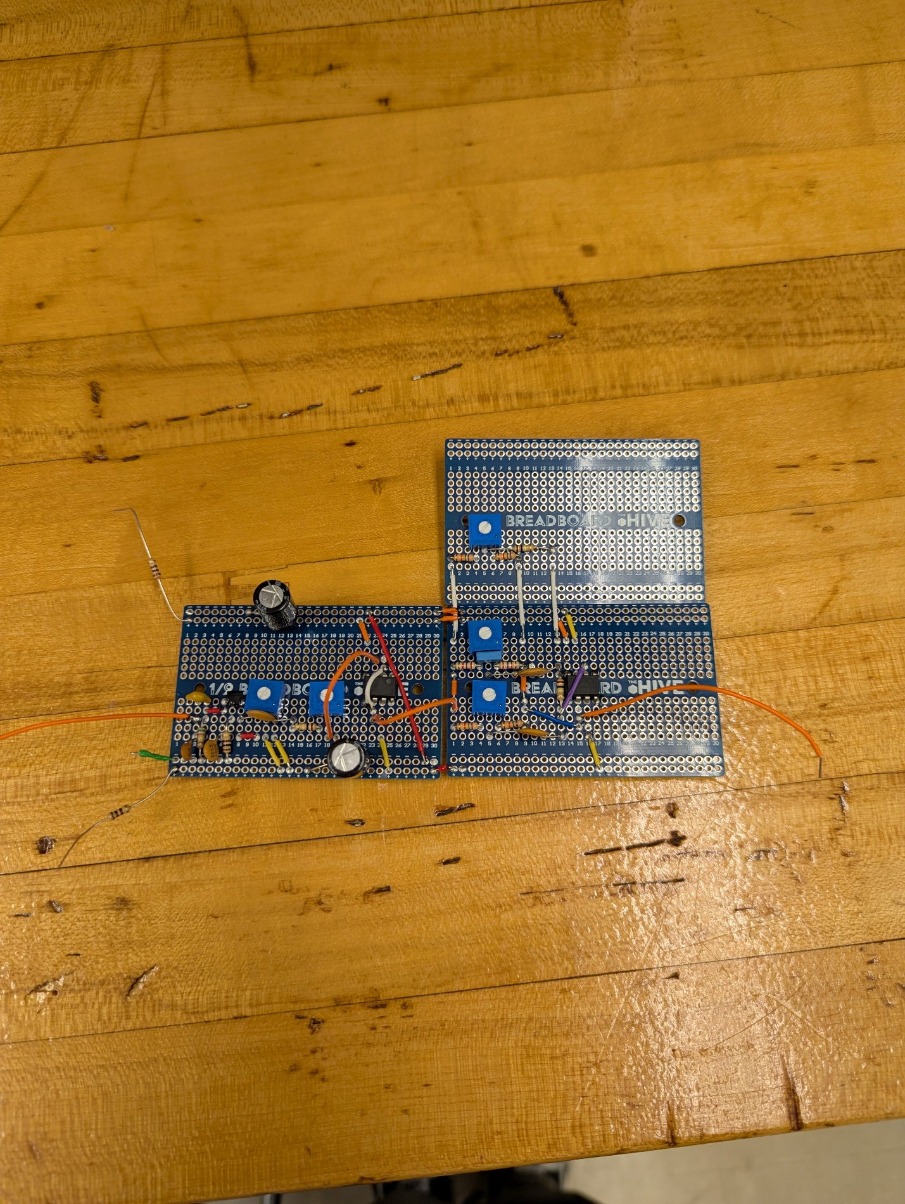

The Driver
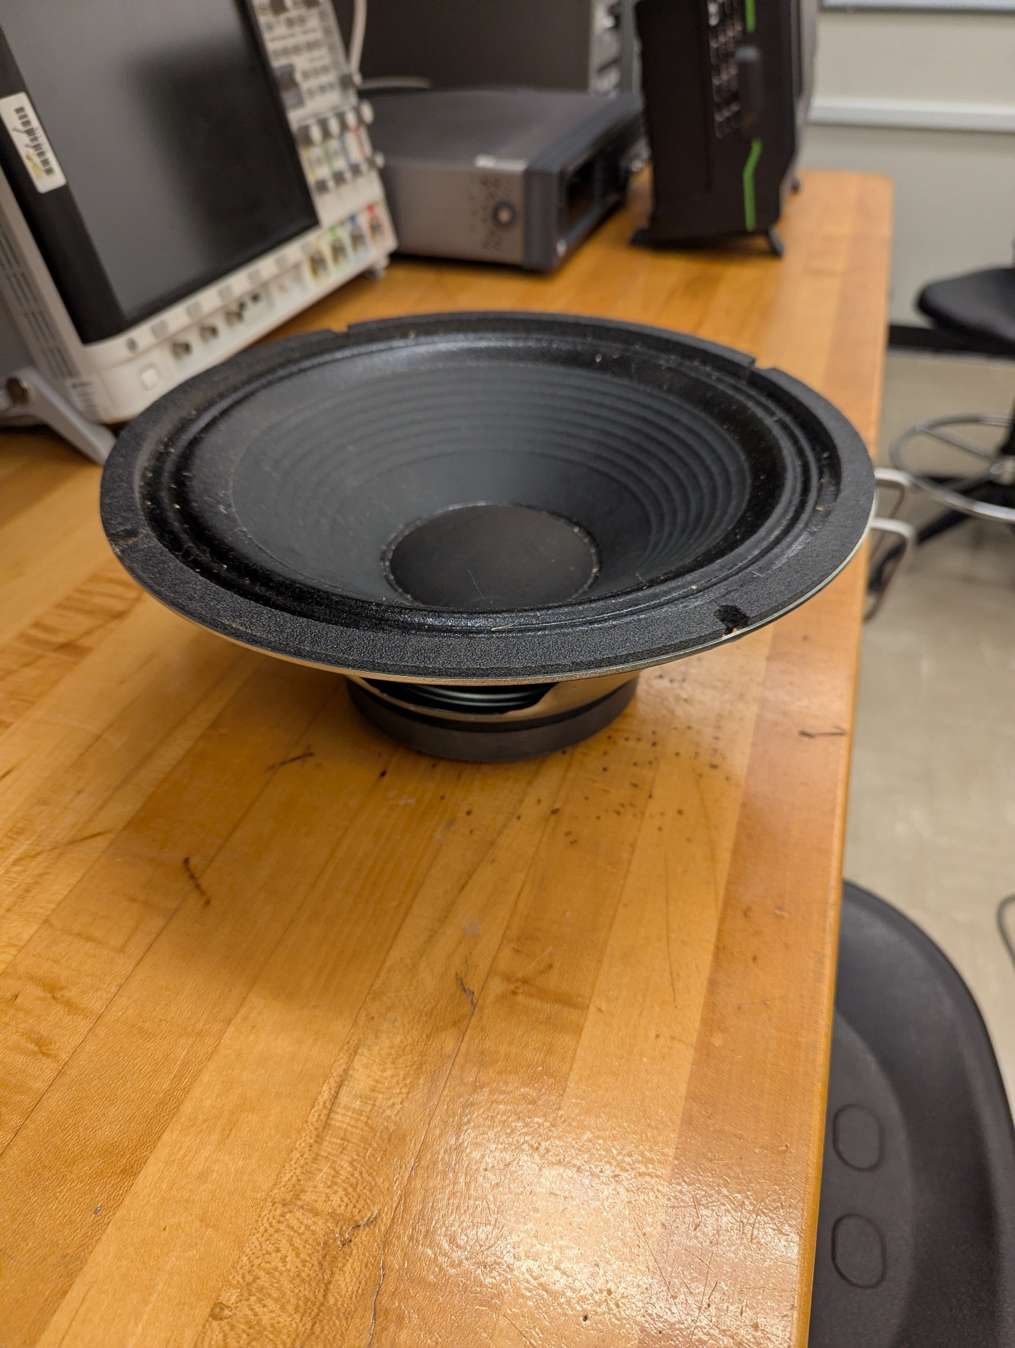

Feedback From Dr. Robinson
Dr. Robinson’s feedback from the presentation largely involved adding more buffers between effects and stages. This will cause there to be no interaction or loading between cascaded effects. He also suggested decoupling, which is something we have already included in our PCB designs, but not on the protoboards.
He made no comment on how we are planning on cascading the effects but seems to be onboard with our ideas.

